Day of Giving, 17th October 2019
For 24 hours on Thursday 17 October 2019, help us raise funds on our national Day of Giving. All funds raised will go to Edmund Rice Foundation partner programs in Australia and overseas to empower women and girls through education.
The incredible part - all donations given on the day will be QUADRUPLED by some amazing matching donors. What a way to have your gift create change!

Set a reminder or give on the day at www.charidy.com/bff

Image option #1 (WIDE)

Image option #2 (LONG)
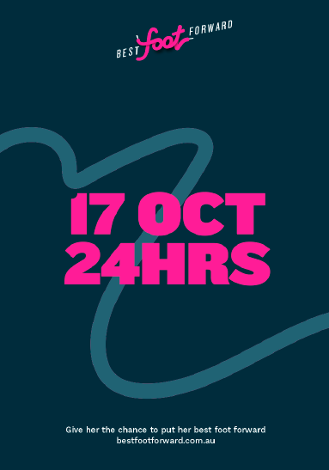

Image option #3 (SQUARE)
